**Work in Progress Documentation**

**The Clehuderfax E-Chain**Team Name: The Influencers (Team 5)  
Project Manager: Rohit Pandey  
  
  
Team Members  
Bijay Giri  
**Dipesh B.C. (77202612)**  
Kadamber Verma  
Rajbir Chand  
Sushant Tiwari

# **Overview**

As national chains have started to find space in Cleckhuddersfax the competition in the market is starting to rise and the traders are afraid that they won’t be able to compete on opening hours without losing out on family life. The Clehuderfax E-Chain project is our solution for this problem. This is a joint E-commerce platform for the locals of Cleckhuddersfax. Not only the traders will now be able to manage their work just by the website sitting at their home without losing out their family time, the peoples that were previously unable to shop in the opening hours because of their work will now they will also be able to shop because of this platform.

**Overview** 2

**Product Planning** 5

**Project Charter** 6

**Belbin’s Analysis** 10

Team Belbin’s Analysis 10

Individual Belbin’s Analysis 15

Bijay Giri 15

Dipesh B.C. 16

Kadamber Verma 17

Rajbir Chand 18

Sushant Tiwari 20

**Skills Audit** 21

Team Skills Audit 21

Individual Skills Audit 25

Bijay Giri 25

Dipesh B.C. 27

Kadamber Verma 29

Rajbir Chand 32

Sushant Tiwari 34

**Project Management** 38

Microsoft Project 38

Task Sheet 38

Gantt Chart 38

Resource Sheet 39

Calendar 39

Timeline 41

**Communication and Collaboration Tools Used** 42

Trello 42

Slack 42

**Product Designing** 45

Entity Relationship Diagram 45

Extended Entity Relationship Diagram 45

Final Composite Entity Relationship Diagram 45

**Use Case Diagram** 46

Overview 46

Customer 47

Trader 47

Admin 49

**Requirement Catalogue** 50

Functional Requirements 50

Part A: Customer Interface 50

Part B: Registration and Login 51

Part C: Trader Interface 52

Part D: Admin Interface 53

Part E: Management Interface 54

Non-Functional Requirements 55

Part F: Non-Functional Requirement 55

# **Product Planning**

The Stores selling fresh goods have decided to band together and explore the possibility of offering a joint e-commerce portal to their shops. As per the initial meeting between traders the website will initially consist of 5 traders i.e. butcher, greengrocer, fishmonger, bakery and delicatessen. These 5 traders have decided not to overlap their product lines and that their product will be unique to them. In the first instance the website will be able to support a maximum of 10 shops. They expect the site to be responsive (must be viewable on mobile, tablet, desktop) and compatible with all the popular browsers. There will be 3 collection slots 10-13, 13-16, 16-19 for the customer. For the pilot these will only be for Wed, Thus, Fri. When placing and paying for their order customers should identify a collection slot, which must be at least 24 hours after placing the order. There will be a maximum of 20 orders per slot.

For the payment PayPal and possibly Stripe will be used. Customers should be able to search their desired product through open search or by product type and product shop. They must register or login before checking out. The management interface will look after every transaction made, activity of traders and customers and generate daily, weekly and monthly report for all traders.

# **Project Charter**

|  |
| --- |
| Project Title: The Clehuderfax e-chain  Sponsored by: The British College, Thapathali, Kathmandu  Manager: Rohit Pandey  Leader: Bijay Giri  Team Name: The Influencers  Target Customer: Local Traders of Cleckhuddersfax |

Version Control

|  |  |  |
| --- | --- | --- |
| Version | Date | Summary of changes |
| 1 | 2/19/2020 | *Initial version* |
|  |  |  |
|  |  |  |

Project Justification

|  |
| --- |
| As the national chains have started to find space in Cleckhuddersfax by setting up convenience stores and are proposing to develop even larger stores, the traders in that area have congregated to start an online portal for their shops. This will help the traders contend with the bigger store on opening hours without losing their family time.  People's reliance on their local shopping area and the continued growth of local independent businesses is evidence that customers can be attracted to the ecommerce platform. And this online portal will solve the problem of locals being not able to shop as they were working most of the time when the shops were open. Traders are producing locally sourced, high-quality goods which are getting increasingly popular but cannot be purchased through local supermarkets.  So, this online portal will help the traders sell these goods to the local market on click and collect basis and will provide the customers better and easy shopping experience. |

Project Scope

|  |
| --- |
| 1. *Increase weekly product sales by 25 percent in 6 months.* 2. *Increase the website’s sales conversion rate by 5 percent in 2 months.* 3. *Attract new customers that would otherwise not be able to shop with the traders.* 4. *Improve sales support online to increase closing rate by 5 percent in 12 months.* 5. *Improve customer satisfaction overtime via online polls and surveys.* |
| *High level requirements:*   1. ***Customer Interface***    1. *Website with a theme that reflects heritage of the area and open to new and creative ideas.*    2. *At least five traders support system with maximum 10 shops.*    3. *Product search functionality by shop categories and products.*    4. *Cart and add to favourites function for products.*    5. *User login and registration functionality.*    6. *Email confirmation for new user registration.*    7. *Product collection slot.*    8. *Product invoice delivery to the customers.*    9. *Responsiveness feature on mobile devices and major web browsers including internet explorer.*    10. *PayPal, Stripe payment gateway implementation.*    11. *Product rating and product review.* 2. ***Trader Interface***    1. *CMS system for creating, managing, and modifying products.*    2. *Traders login system.*    3. *Product invoice delivery to corresponding product traders.*    4. *Database login function for traders for viewing orders and stock levels.*    5. *Admin login feature with authority to access the entire system.* 3. ***Management Interface***   *3.1 Management dashboard for accessing daily and periodic reports.*  *3.2 Daily report on orders placed for the traders.*  *3.3 Monthly product sales report for the traders.*  *3.4 Weekly finance report of products that have been delivered.* |
| *Major deliverables:*   1. *Unique user interface for customer, trader and management.* 2. *Oracle Interface as a backend for database.* |

Duration

|  |
| --- |
| *Initial prototype presentation – 24th March 2020*  *Deployment for testing – 18Th April 2020*  *Final submission – 3rd May 2020* |

Estimated Budget

|  |
| --- |
| No initial hardware requirements.  Hours per week per person 8-10  Team of 5  Hence, total hours min: 8*5*12 =480 hours max: 10*5*12= 600hours |

Roles and Responsibilities

|  |  |
| --- | --- |
| **Name** | **Roles** |
| Bijay Giri | Co-ordinator, Specialist, Monitor Evaluator |
| Dipesh B.C. | Specialist, Plant, Co-ordinator |
| Kadamber Verma | Implementor, Complete Finisher, Resource Investigator |
| Rajbir Chand | Shaper, Monitor Evaluator, Resource Investigator |
| Sushant Tiwari | Team worker, Co-ordinator, Resource Investigator |

Communication and Collaboration Tools

|  |
| --- |
| 1. ***Slack*** *– For team communication and collaboration at one place.* 2. ***Trello*** *- For progress tracking.* 3. ***GitHub*** *– For version control and documentation.* 4. ***MS******Project*** *– For Task tracking and documentation.* 5. ***Taiga.io*** *– For project progress tracking.* 6. ***Team meetings*** *– 3 to 4 meetings will be held each week for feedback, discussion and promoting team collaboration.* |

# **Belbin’s Analysis**

## Team Belbin’s Analysis

|  |  |  |
| --- | --- | --- |
| Version:1.0 **Belbin’s Analysis** Date reviewed: | | |
| Primary role | Bijay Giri | Co-ordinator |
| Dipesh B.C. | Specialist |
| Kadamber Verma | Implementor |
| Rajbir Chand | Shaper |
| Sushanti Tiwari | Team Worker |
| Secondary role | Bijay Giri | Specialist |
| Dipesh B.C. | Plant |
| Kadamber Verma | Complete Finisher |
| Rajbir Chand | Monitor Evaluator |
| Sushant Tiwari | Co-ordinator |
| Least likely role | Bijay Giri | Monitor Evaluator |
| Dipesh B.C. | Co-ordinator |
| Kadamber Verma | Resource Investigator |
| Rajbir Chand | Resource Investigator |
| Sushant Tiwari | Resource Investigator |
| Do you think the descriptions of these roles are an accurate description of your behaviour in teams? How do you see yourself differently? | Bijay Giri | Yes, the descriptions of these roles are an accurate description of my behaviour. I see myself differently as there is diplomacy and strategizing in most of the decisions I make. |
| Dipesh B.C. | Yes, the descriptions of these roles are an accurate description of my behaviour. I see myself differently in the way I solve problems in my daily life and my helping behaviour with others. |
| Kadamber Verma | Yes, I believe the above roles are verified to my description and my skills, I came up with. I don’t see myself differently in the wide sense though I slightly remember all the time that I assure the work and accuracy of the work before I proceed on the task to complete. |
| Rajbir Chand | Yes, I think that the above roles that I have defined for myself define me the way I am in real life. And therefore, I don’t see myself anywhere differently than what I have already described. |
| Sushant Tiwari | Yes, the descriptions of these roles are an accurate description of my behaviour. I see myself differently as there is diplomacy and strategizing in most of the decisions I make. |
| Are there roles identified by Belbin that you might like to develop in yourself more? Which ones and why? | Bijay Giri | Yes, I would like to mention that there is one role that I would like to develop more and that is Co-ordinator. I want to develop this role because the Co-ordinator is the one who manages the team and plans the working and divides the work equally to all group members in a team which ultimately leads to better team working and efficiency in group work. |
| Dipesh B.C. | Yes, there is a role I would like to develop and become better at and that is team worker. Developing this role is important for me because in future most of the time I must work with a team where I will meet team members of different natures with attitudes. Cooperating with the team and helping them is the key of success to finish any work in each time. |
| Kadamber Verma | I have already assigned myself for the multiple roles I mentioned above. Although, I would love to develop a role of “Specialist” which I’m lacking that I will be strengthen soon to become more productive in order to perform specific and potential task. |
| Rajbir Chand | Now that I already have three of the roles described for myself for which I am already capable of so therefore the one role I would like to develop more In, the coming years is that of the “Specialist”. Simply the reason being I am not good at it, so I hope I gain some knowledge for that skill set. |
| Sushant Tiwari | I have already mentioned my primary role, but Co-ordinator is a role where I would like to improve my quality. Because Co-ordinator is a backbone of a Group. |
| What possible situations in the coming months can you identify where you could work on developing these skills? | Bijay Giri | Situations like when a group member is not working as expected or when a group member is not cooperating with the team. |
| Dipesh B.C. | Situations like when one or more of my team members are sick or when they are unreachable or when they might have to deal with stuff of higher importance is where I could come in handy and develop my team working skills. |
| Kadamber Verma | There might be various possible situations in the future that will define the skills I’m working with currently, Because I’m engaged in the multiple roles in the project, so I have wide range of opportunity to sharp my skills in the future. |
| Rajbir Chand | We in the team have decided to go with the rotating kind of leadership which will create a chance not only for me but for everyone else. So, I consider that as one of the situations where I can work to enhance my skill set for that role. |
| Sushant Tiwari | Situations like when a group member is not working as expected or when a group member is not cooperating with the team. |
| Considering your team working, how do you think you could improve your effectiveness in group work and in contributing to the success of teams that you work in? | Bijay Giri | Becoming more confident in my decision making and better at recognising others talent will help me improve my effectiveness in group work and in contributing to the success of teams I work in. |
| Dipesh B.C. | I think that by being more social and more diplomatic I could improve our effectiveness in group work and by contributing to the success of the team. |
| Kadamber Verma | Me as one of the team members of my team working by carrying an effective set of responsibilities. All of us has been assigned to be dedicated to the project. Me as a part, I came up with high determination to fulfil the work needs required to my roles and responsibilities. I could be a remarkable example throughout group if I could able to turn my ideas into actions more than I can ever in the present scenario. I’m dedicated to my ideas to contribute for the success of my team. |
| Rajbir Chand | This could be done by regularly attending meetings that will be held in the group because I think punctuality already contributes to the effectiveness of anything. And yes, the other solution can also be participating and contributing towards the team objectives effectively. |
| Sushant Tiwari | I think that by being Confident and diplomatic. I could improve our effectiveness in group work and by helping to success our team. |
| Are the results of this inventory consistent with how you worked in the Foundation Project in your small groups for discussions and presentations? | Bijay Giri | The results of this inventory are almost consistent with the Foundation Project that I worked in with my small groups for discussions and presentations. |
| Dipesh B.C. | Yes, the results of this inventory are almost consistent with Foundation Projects. There are some slight changes as this exercise contain continuous documentation of each task done and regular update on improvement of the project. |
| Kadamber Verma | Since the initialization of the foundation project I have been giving my effective presence in the team by considering issues, roles and time. I found consistent results of all the founding projects because of strong bond and communication between the team members. Moreover, working in a small group have been structured well between so that we meet all the requirements and the objectives that a project holds. |
| Rajbir Chand | Till date everything has been going smoothly and effectively. So, in a way I could say that for the time being everything is consistent, and all this could be proven by because we have been meeting every assignment deadline by their specified dates of submission. |
| Sushant Tiwari | Yes, results of this inventory are almost consistent with the Foundation Project where I worked in with my small groups for discussions and presentations. |
| How well do you want to contribute to group presentations? | Bijay Giri | I want to give my best effort in my group presentations. |
| Dipesh B.C. | I want to give my best effort in my group presentations. |
| Kadamber Verma | If I talk about my contribution, I’m being very well planned, and environment orientated. Before I stand for the presentation, I make concrete plan from abstract ideas in self- controlled manner. I disregard my self-interest to focus on the needs of a team and presentation work. I likely persuade myself to change if I feel that the change will yield positive results to group presentation as well as individually. |
| Rajbir Chand | According to me I have been contributing well enough to the group and the reason being that I regularly attend all meetings and also bring in important changes to be made in the project and also keep adding up resources for the group to make effective use of. |
| Sushant Tiwari | I want to give my best in our group presentations. |

## Individual Belbin’s Analysis

### Bijay Giri

|  |  |  |
| --- | --- | --- |
| Version:1.0 **Belbin’s Analysis** Date reviewed: | | |
| Primary role | Bijay Giri | Co-ordinator |
| Secondary role | Bijay Giri | Specialist |
| Least likely role | Bijay Giri | Monitor Evaluator |

**Your Name: Bijay Giri**

|  |  |  |
| --- | --- | --- |
| Do you think the descriptions of these roles are an accurate description of your behaviour in teams? How do you see yourself differently? | Bijay Giri | Yes, the descriptions of these roles are an accurate description of my behaviour. I see myself differently as there is diplomacy and strategizing in most of the decisions I make. |
| Are there roles identified by Belbin that you might like to develop in yourself more? Which ones and why? | Bijay Giri | Yes, I would like to mention that there is one role that I would like to develop more and that is Co-ordinator. I want to develop this role because the Co-ordinator is the one who manages the team and plans the working and divides the work equally to all group members in a team which ultimately leads to better team working and efficiency in group work. |
| What possible situations in the coming months can you identify where you could work on developing these skills? | Bijay Giri | Situations like when a group member is not working as expected or when a group member is not cooperating with the team. |
| Considering your team working, how do you think you could improve your effectiveness in group work and in contributing to the success of teams that you work in? | Bijay Giri | Becoming more confident in my decision making and better at recognising others talent will help me improve my effectiveness in group work and in contributing to the success of teams I work in. |
| Are the results of this inventory consistent with how you worked in the Foundation Project in your small groups for discussions and presentations? | Bijay Giri | The results of this inventory are almost consistent with the Foundation Project that I worked in with my small groups for discussions and presentations. |
| How well do you want to contribute to group presentations? | Bijay Giri | I want to give my best effort in my group presentations. |

### Dipesh B.C.

|  |  |  |
| --- | --- | --- |
| Version:1.0 **Belbin’s Analysis** Date reviewed: | | |
| Primary role | Dipesh B.C. | Specialist |
| Secondary role | Dipesh B.C. | Plant |
| Least likely role | Dipesh B.C. | Co-ordinator |

**Your Name: Dipesh B.C.**

|  |  |  |
| --- | --- | --- |
| Do you think the descriptions of these roles are an accurate description of your behaviour in teams? How do you see yourself differently? | Dipesh B.C. | Yes, the descriptions of these roles are an accurate description of my behaviour. I see myself differently in the way I solve problems in my daily life and my helping behaviour with others. |
| Are there roles identified by Belbin that you might like to develop in yourself more? Which ones and why? | Dipesh B.C. | Yes, there is a role I would like to develop and become better at and that is team worker. Developing this role is important for me because in future most of the time I must work with a team where I will meet team members of different natures with attitudes. Cooperating with the team and helping them is the key of success to finish any work in each time. |
| What possible situations in the coming months can you identify where you could work on developing these skills? | Dipesh B.C. | Situations like when one or more of my team members are sick or when they are unreachable or when they might have to deal with stuff of higher importance is where I could come in handy and develop my team working skills. |
| Considering your team working, how do you think you could improve your effectiveness in group work and in contributing to the success of teams that you work in? | Dipesh B.C. | I think that by being more social and more diplomatic I could improve our effectiveness in group work and by contributing to the success of the team. |
| Are the results of this inventory consistent with how you worked in the Foundation Project in your small groups for discussions and presentations? | Dipesh B.C. | Yes, the results of this inventory are almost consistent with Foundation Projects. There are some slight changes as this exercise contain continuous documentation of each task done and regular update on improvement of the project. |
| How well do you want to contribute to group presentations? | Dipesh B.C. | I want to give my best effort in my group presentations. |

### Kadamber Verma

|  |  |  |
| --- | --- | --- |
| Version:1.0 **Belbin’s Analysis** Date reviewed: | | |
| Primary role | Kadamber Verma | Implementor |
| Secondary role | Kadamber Verma | Complete Finisher |
| Least likely role | Kadamber Verma | Resource Investigator |

**Your Name: Kadamber Verma**

|  |  |  |
| --- | --- | --- |
| Do you think the descriptions of these roles are an accurate description of your behaviour in teams? How do you see yourself differently? | Kadamber Verma | Yes, I believe the above roles are verified to my description and my skills, I came up with. I don’t see myself differently in the wide sense though I slightly remember all the time that I assure the work and accuracy of the work before I proceed on the task to complete. |
| Are there roles identified by Belbin that you might like to develop in yourself more? Which ones and why? | Kadamber Verma | I have already assigned myself for the multiple roles I mentioned above. Although, I would love to develop a role of “Specialist” which I’m lacking that I will be strengthen soon to become more productive in order to perform specific and potential task. |
| What possible situations in the coming months can you identify where you could work on developing these skills? | Kadamber Verma | There might be various possible situations in the future that will define the skills I’m working with currently, Because I’m engaged in the multiple roles in the project, so I have wide range of opportunity to sharp my skills in the future. |
| Considering your team working, how do you think you could improve your effectiveness in group work and in contributing to the success of teams that you work in? | Kadamber Verma | Me as one of the team members of my team working by carrying an effective set of responsibilities. All of us has been assigned to be dedicated to the project. Me as a part, I came up with high determination to fulfil the work needs required to my roles and responsibilities. I could be a remarkable example throughout group if I could able to turn my ideas into actions more than I can ever in the present scenario. I’m dedicated to my ideas to contribute for the success of my team. |
| Are the results of this inventory consistent with how you worked in the Foundation Project in your small groups for discussions and presentations? | Kadamber Verma | Since the initialization of the foundation project I have been giving my effective presence in the team by considering issues, roles and time. I found consistent results of all the founding projects because of strong bond and communication between the team members. Moreover, working in a small group have been structured well between so that we meet all the requirements and the objectives that a project holds. |
| How well do you want to contribute to group presentations? | Kadamber Verma | If I talk about my contribution, I’m being very well planned, and environment orientated. Before I stand for the presentation, I make concrete plan from abstract ideas in self- controlled manner. I disregard my self-interest to focus on the needs of a team and presentation work. I likely persuade myself to change if I feel that the change will yield positive results to group presentation as well as individually. |

### Rajbir Chand

|  |  |  |
| --- | --- | --- |
| Version:1.0 **Belbin’s Analysis** Date reviewed: | | |
| Primary role | Rajbir Chand | Shaper |
| Secondary role | Rajbir Chand | Monitor Evaluator |
| Least likely role | Rajbir Chand | Resource Investigator |

**Your Name: Rajbir Chand**

|  |  |  |
| --- | --- | --- |
| Do you think the descriptions of these roles are an accurate description of your behaviour in teams? How do you see yourself differently? | Rajbir Chand | Yes, I think that the above roles that I have defined for myself define me the way I am in real life. And therefore, I don’t see myself anywhere differently than what I have already described. |
| Are there roles identified by Belbin that you might like to develop in yourself more? Which ones and why? | Rajbir Chand | Now that I already have three of the roles described for myself for which I am already capable of so therefore the one role I would like to develop more In, the coming years is that of the “Specialist”. Simply the reason being I am not good at it, so I hope I gain some knowledge for that skill set. |
| What possible situations in the coming months can you identify where you could work on developing these skills? | Rajbir Chand | We in the team have decided to go with the rotating kind of leadership which will create a chance not only for me but for everyone else. So, I consider that as one of the situations where I can work to enhance my skill set for that role. |
| Considering your team working, how do you think you could improve your effectiveness in group work and in contributing to the success of teams that you work in? | Rajbir Chand | This could be done by regularly attending meetings that will be held in the group because I think punctuality already contributes to the effectiveness of anything. And yes, the other solution can also be participating and contributing towards the team objectives effectively. |
| Are the results of this inventory consistent with how you worked in the Foundation Project in your small groups for discussions and presentations? | Rajbir Chand | Till date everything has been going smoothly and effectively. So, in a way I could say that for the time being everything is consistent, and all this could be proven by because we have been meeting every assignment deadline by their specified dates of submission. |
| How well do you want to contribute to group presentations? | Rajbir Chand | According to me I have been contributing well enough to the group and the reason being that I regularly attend all meetings and also bring in important changes to be made in the project and also keep adding up resources for the group to make effective use of. |

### Sushant Tiwari

|  |  |  |
| --- | --- | --- |
| Version:1.0 **Belbin’s Analysis** Date reviewed: | | |
| Primary role | Sushant Tiwari | **Team worker** |
| Secondary role | Sushant Tiwari | **Co-ordinator** |
| Least likely role | Sushant Tiwari | **Resource Investigator** |

**Your Name: Sushant Tiwari**

|  |  |  |
| --- | --- | --- |
| Do you think the descriptions of these roles are an accurate description of your behaviour in teams? How do you see yourself differently? | Sushant Tiwari | Yes, the descriptions of these roles are an accurate description of my behaviour. I see myself differently as there is diplomacy and strategizing in most of the decisions I make. |
| Are there roles identified by Belbin that you might like to develop in yourself more? Which ones and why? | Sushant Tiwari | I have already mentioned my primary role, but Co-ordinator is a role where I would like to improve my quality. Because Co-ordinator is a backbone of a Group. |
| What possible situations in the coming months can you identify where you could work on developing these skills? | Sushant Tiwari | Situations like when a group member is not working as expected or when a group member is not cooperating with the team. |
| Considering your team working, how do you think you could improve your effectiveness in group work and in contributing to the success of teams that you work in? | Sushant Tiwari | I think that by being Confident and diplomatic. I could improve our effectiveness in group work and by helping to success our team. |
| Are the results of this inventory consistent with how you worked in the Foundation Project in your small groups for discussions and presentations? | Sushant Tiwari | Yes, results of this inventory are almost consistent with the Foundation Project where I worked in with my small groups for discussions and presentations. |
| How well do you want to contribute to group presentations? | Sushant Tiwari | I want to give my best in our group presentations. |

# **Skills Audit**

## Team Skills Audit

|  |  |  |  |  |  |  |  |
| --- | --- | --- | --- | --- | --- | --- | --- |
| 1 | PHP Programming | 3 | Follow youtube tutorials and PHP official documentation. | Become more confident in the use of PHP and in particular in the building of shopping cart. | 2 | 3/8/2019 | Dipesh B.C., Bijay Giri, Rajbir Chand, Kadamber Verma, Sushant Tiwari. |
| 2 | Bootstrap | 3 | Follow youtube tutorials and Bootstrap official documentation. | Become more confident in the use of Bootstrap and in particular in the building of responsive website. | 2 | 3/8/2019 | Dipesh B.C., Bijay Giri, Rajbir Chand, Kadamber Verma, Sushant Tiwari. |
| 3 | Front End Design | 3.8 | Follow w3school link and HTML/CSS Tutorial. | Become more confident in the use of wireframe and to build attractive and user-friendly website design. | 2 | 3/8/2019 | Dipesh B.C., Bijay Giri, Rajbir Chand, Kadamber Verma, Sushant Tiwari. |
| 4 | Wireframe | 4.4 | Follow youtube tutorials and study materials from college. | Become more confident in the use of wireframe and to design a better page layout or arrangement of the website's content, including interface elements and navigational systems. | 2 | 3/8/2019 | Dipesh B.C., Bijay Giri, Rajbir Chand, Kadamber Verma, Sushant Tiwari. |
| 5 | Mindmap | 4.6 | Follow youtube tutorials. | Become better at representing ideas and concepts. | 2 | 3/8/2019 | Dipesh B.C., Bijay Giri, Rajbir Chand, Kadamber Verma, Sushant Tiwari. |
| 6 | Photoshop | 4 | Follow youtube tutorials. | To develop skills in editing and altering photographs for the website. | 2 | 3/8/2019 | Dipesh B.C., Bijay Giri, Rajbir Chand, Kadamber Verma, Sushant Tiwari. |
| 7 | Illustrator | 4 | Follow youtube tutorials. | Helps in developing logo for our website. | 2 | 3/8/2019 | Dipesh B.C., Bijay Giri, Rajbir Chand, Kadamber Verma, Sushant Tiwari. |
| 8 | EERD/ERD/UML/Conceptual Design | 4.2 | Follow Youtube tutorials and study materials from college. | Become better at creating database and to create a well managed database for our website. | 2 | 3/8/2019 | Dipesh B.C., Bijay Giri, Rajbir Chand, Kadamber Verma, Sushant Tiwari. |
| 9 | Java Script | 2.8 | Follow MDN web docs and youtube tutorials. | Become more confident in the use of Java Script and in particular in the event handling using AJAX request from website elements. | 2 | 3/8/2019 | Dipesh B.C., Bijay Giri, Rajbir Chand, Kadamber Verma, Sushant Tiwari. |
| 10 | Apex Oracle | 3.6 | Follow youtube tutorials and official Oracle documentation. | To create interface for our website's backend. | 2 | 3/8/2019 | Dipesh B.C., Bijay Giri, Rajbir Chand, Kadamber Verma, Sushant Tiwari. |
| 11 | MS project | 3 | Follow youtube tutorials and study materials from college. | Become better at developing plans, assigning resources to tasks, tracking progress, managing budgets and analysing workloads. | 2 | 3/8/2019 | Dipesh B.C., Bijay Giri, Rajbir Chand, Kadamber Verma, Sushant Tiwari. |
| 12 | Oracle Database | 2.8 | Follow youtube tutorials and official Oracle documentation. | To create table and store data. | 2 | 3/8/2019 | Dipesh B.C., Bijay Giri, Rajbir Chand, Kadamber Verma, Sushant Tiwari. |
| 13 | API | 2.8 | Follow youtube tutorials and API developer documentation. | To implement payment gateway. | 2 | 3/8/2019 | Dipesh B.C., Bijay Giri, Rajbir Chand, Kadamber Verma, Sushant Tiwari. |
| 14 | PL/SQL | 3.4 | Follow youtube tutorials and references from TutorialsPoint. | To manipule, collect large volume of data and apply algorithms. | 2 | 3/8/2019 | Dipesh B.C., Bijay Giri, Rajbir Chand, Kadamber Verma, Sushant Tiwari. |
| 15 | Slack, Trello | 4.4 | Follow youtube tutorials. | To become better manage communication, events and in tracking progress. | 2 | 3/8/2019 | Dipesh B.C., Bijay Giri, Rajbir Chand, Kadamber Verma, Sushant Tiwari. |
| 16 | Github | 3.8 | Folllow youtube tutorials. | To become better at tools provided by GitHub for version control of our website. | 2 | 3/8/2019 | Dipesh B.C., Bijay Giri, Rajbir Chand, Kadamber Verma, Sushant Tiwari. |
| 17 | Adobe XD | 3 | Follow youtube tutorials. | To develop prototype for user experience. | 2 | 3/8/2019 | Dipesh B.C., Bijay Giri, Rajbir Chand, Kadamber Verma, Sushant Tiwari. |
| 18 | Microsoft Powerpoint | 4.2 | Follow youtube tutorials. | To make professional presentation for our website. | 2 | 3/8/2019 | Dipesh B.C., Bijay Giri, Rajbir Chand, Kadamber Verma, Sushant Tiwari. |

## Individual Skills Audit

### Bijay Giri

|  |  |  |  |  |  |  |  |
| --- | --- | --- | --- | --- | --- | --- | --- |
| 1 | PHP Programming | 3 | Follow youtube tutorials and PHP official documentation. | Become more confident in the use of PHP and in the building of shopping cart. | 2 | 3/1/2020 | Bijay Giri |
| 2 | Bootstrap | 4 | Follow youtube tutorials and Bootstrap official documentation. | Become more confident in the use of Bootstrap and in the building of responsive website. | 2 | 3/1/2020 | Bijay Giri |
| 3 | Front End Design | 5 | Follow w3school link and HTML/CSS Tutorial. | Become more confident in the use of wireframe and to build attractive and user-friendly website design. | 1 | 3/1/2020 | Bijay Giri |
| 4 | Wireframe | 5 | Follow youtube tutorials and study materials from college. | Become more confident in the use of wireframe and to design a better page layout or arrangement of the website's content, including interface elements and navigational systems. | 1 | 3/1/2020 | Bijay Giri |
| 5 | Mindmap | 5 | Follow youtube tutorials. | Become better at representing ideas and concepts. | 1 | 3/1/2020 | Bijay Giri |
| 6 | Photoshop | 4 | Follow youtube tutorials. | To develop skills in editing and altering photographs for the website. | 2 | 3/8/2020 | Bijay Giri |
| 7 | Illustrator | 4 | Follow youtube tutorials. | Helps in developing logo for our website. | 2 | 3/8/2020 | Bijay Giri |
| 8 | EERD/ERD/UML/Conceptual Design | 5 | Follow Youtube tutorials and study materials from college. | Become better at creating database and to create a well-managed database for our website. | 1 | 3/1/2020 | Bijay Giri |
| 9 | Java Script | 3 | Follow MDN web docs and youtube tutorials. | Become more confident in the use of Java Script and in the event handling using AJAX request from website elements. | 2 | 3/8/2020 | Bijay Giri |
| 10 | Apex Oracle | 4 | Follow youtube tutorials and official Oracle documentation. | To create interface for our website's backend. | 2 | 3/1/2020 | Bijay Giri |
| 11 | MS project | 3 | Follow youtube tutorials and study materials from college. | Become better at developing plans, assigning resources to tasks, tracking progress, managing budgets and analysing workloads. | 2 | 3/8/2020 | Bijay Giri |
| 12 | Oracle Database | 3 | Follow youtube tutorials and official Oracle documentation. | To create table and store data. | 2 | 3/8/2020 | Bijay Giri |
| 13 | API | 3 | Follow youtube tutorials and API developer documentation. | To implement payment gateway. | 2 | 3/1/2020 | Bijay Giri |
| 14 | PL/SQL | 4 | Follow youtube tutorials and references from TutorialsPoint. | To manipule, collect large volume of data and apply algorithms. | 2 | 3/1/2020 | Bijay Giri |
| 15 | Slack, Trello | 5 | Follow youtube tutorials. | To become better manage communication, events and in tracking progress. | 1 | 3/1/2020 | Bijay Giri |
| 16 | Github | 3 | Folllow youtube tutorials. | To become better at tools provided by GitHub for version control and documentation of our website. | 2 | 3/1/2020 | Bijay Giri |
| 17 | Adobe XD | 3 | Follow youtube tutorials. | To develop prototype for user experience. | 2 | 3/8/2020 | Bijay Giri |
| 18 | Microsoft Powerpoint | 4 | Follow youtube tutorials. | To make professional presentation for our website. | 2 | 3/1/2020 | Bijay Giri |

### Dipesh B.C.

|  |  |  |  |  |  |  |  |
| --- | --- | --- | --- | --- | --- | --- | --- |
| 1 | PHP Programming | 5 | Follow youtube tutorials and PHP official documentation. | Become more confident in the use of PHP and in the building of shopping cart. | 1 | 3/1/2020 | Dipesh B.C. |
| 2 | Bootstrap | 4 | Follow youtube tutorials and Bootstrap official documentation. | Become more confident in the use of Bootstrap and in the building of responsive website. | 2 | 3/1/2020 | Dipesh B.C. |
| 3 | Front End Design | 5 | Follow w3school link and HTML/CSS Tutorial on MDN web docs. | Become more confident in the use of wireframe and to build attractive and user-friendly website design. | 1 | 3/1/2020 | Dipesh B.C. |
| 4 | Wireframe | 5 | Follow youtube tutorials and study materials from college. | Become more confident in the use of wireframe and to design a better page layout or arrangement of the website's content, including interface elements and navigational systems. | 1 | 3/1/2020 | Dipesh B.C. |
| 5 | Mindmap | 5 | Follow youtube tutorials. | Become better at representing ideas and concepts. | 1 | 3/1/2020 | Dipesh B.C. |
| 6 | Photoshop | 3 | Follow youtube tutorials. | To develop skills in editing and altering photographs for the website. | 2 | 3/8/2020 | Dipesh B.C. |
| 7 | Illustrator | 3 | Follow youtube tutorials. | Helps in developing logo for our website. | 2 | 3/8/2020 | Dipesh B.C. |
| 8 | EERD/ERD/UML/Conceptual Design | 5 | Follow Youtube tutorials and study materials from college. | Become better at creating database and to create a well-managed database for our website. | 1 | 3/1/2020 | Dipesh B.C. |
| 9 | Java Script | 3 | Follow MDN web docs and youtube tutorials. | Become more confident in the use of Java Script and in the event handling using AJAX request from website elements. | 2 | 3/8/2020 | Dipesh B.C. |
| 10 | Apex Oracle | 4 | Follow youtube tutorials and official Oracle documentation. | To create interface for our website's backend. | 2 | 3/1/2020 | Dipesh B.C. |
| 11 | MS project | 3 | Follow youtube tutorials and study materials from college. | Become better at developing plans, assigning resources to tasks, tracking progress, managing budgets and analysing workloads. | 2 | 3/8/2020 | Dipesh B.C. |
| 12 | Oracle Database | 3 | Follow youtube tutorials and official Oracle documentation. | To create table and store data. | 2 | 3/8/2020 | Dipesh B.C. |
| 13 | API | 4 | Follow youtube tutorials and API developer documentation. | To implement payment gateway. | 2 | 3/1/2020 | Dipesh B.C. |
| 14 | PL/SQL | 4 | Follow youtube tutorials and references from TutorialsPoint. | To manipule, collect large volume of data and apply algorithms. | 2 | 3/1/2020 | Dipesh B.C. |
| 15 | Slack, Trello | 5 | Follow youtube tutorials. | To become better manage communication, events and in tracking progress. | 1 | 3/1/2020 | Dipesh B.C. |
| 16 | Github | 5 | Folllow youtube tutorials. | To become better at tools provided by GitHub for version control and documentation of our website. | 1 | 3/1/2020 | Dipesh B.C. |
| 17 | Adobe XD | 3 | Follow youtube tutorials. | To develop prototype for user experience. | 2 | 3/8/2020 | Dipesh B.C. |
| 18 | Documentation | 4 | Follow youtube tutorials. | To make professional documentation for our website. | 2 | 3/1/2020 | Dipesh B.C. |

### Kadamber Verma

|  |  |  |  |  |  |  |  |
| --- | --- | --- | --- | --- | --- | --- | --- |
| 1 | PHP Programming | 3 | Follow youtube tutorials and PHP official documentation. | Become more confident in the use of PHP and in particular in the building of shopping cart. | 2 | 3/8/2020 | Kadamber Verma |
| 2 | Bootstrap | 3 | Follow youtube tutorials and Bootstrap official documentation. | Become more confident in the use of Bootstrap and in particular in the building of responsive website. | 2 | 3/6/2020 | Kadamber Verma |
| 3 | Front End Design | 4 | Follow w3school link and HTML/CSS Tutorial. | Become more confident in the use of wireframe and to build attractive and user friendly website design. | 2 | 3/6/2020 | Kadamber Verma |
| 4 | Wireframe | 4 | Follow youtube tutorials and study materials from college. | Become more confident in the use of wireframe and to design a better page layout or arrangement of the website's content, including interface elements and navigational systems. | 2 | 3/3/2020 | Kadamber Verma |
| 5 | Mindmap | 4 | Follow youtube tutorials. | Become better at representing ideas and concepts. | 2 | 3/1/2020 | Kadamber Verma |
| 6 | Photoshop | 5 | Follow youtube tutorials. | To develop skills in editing and altering photographs for the website. | 1 | 3/3/2020 | Kadamber Verma |
| 7 | Illustrator | 5 | Follow youtube tutorials. | Helps in developing logo for our website. | 1 | 3/6/2020 | Kadamber Verma |
| 8 | EERD/ERD/UML/Conceptual Design | 4 | Follow Youtube tutorials and study materials from college. | Become better at creating database and to create a well managed database for our website. | 2 | 3/3/2020 | Kadamber Verma |
| 9 | Java Script | 3 | Follow MDN web docs and youtube tutorials. | Become more confident in the use of Java Script and in particular in the event handling using AJAX request from website elements. | 2 | 3/8/2020 | Kadamber Verma |
| 10 | Apex Oracle | 4 | Follow youtube tutorials and official Oracle documentation. | To create interface for our website's backend. | 2 | 3/8/2020 | Kadamber Verma |
| 11 | MS project | 4 | Follow youtube tutorials and study materials from college. | Become better at developing plans, assigning resources to tasks, tracking progress, managing budgets and analysing workloads. | 2 | 3/6/2020 | Kadamber Verma |
| 12 | Oracle Database | 3 | Follow youtube tutorials and official Oracle documentation. | To create table and store data. | 2 | 3/8/2020 | Kadamber Verma |
| 13 | API | 3 | Follow youtube tutorials and API developer documentation. | To implement payment gateway. | 2 | 3/8/2020 | Kadamber Verma |
| 14 | PL/SQL | 4 | Follow youtube tutorials and references from TutorialsPoint. | To manipule, collect large volume of data and apply algorithms. | 2 | 3/8/2020 | Kadamber Verma |
| 15 | Slack, Trello | 5 | Follow youtube tutorials. | To become better manage communication, events and in tracking progress. | 1 | 3/3/2020 | Kadamber Verma |
| 16 | Github | 5 | Folllow youtube tutorials. | To become better at tools provided by GitHub for version control of our website. | 1 | 3/8/2020 | Kadamber Verma |
| 17 | Adobe XD | 4 | Follow youtube tutorials. | To develop prototype for user experience. | 2 | 3/6/2020 | Kadamber Verma |
| 18 | Documentation | 5 | Follow youtube tutorials. | To make professional documentation for our website. | 1 | 3/1/2020 | Kadamber Verma |

### Rajbir Chand

|  |  |  |  |  |  |  |  |
| --- | --- | --- | --- | --- | --- | --- | --- |
| 1 | PHP Programming | 2 | Follow E-commerce web site PHP tutorial on Youtube | Become more confident in the use of PHP and making shopping cart | 2 | 3/8/2020 | Rajbir Chand |
| 2 | Bootstrap | 2 | Follow Bootstrap tutorials on Youtube | To build good design of website and make compatible with any device | 2 | 3/8/2020 | Rajbir Chand |
| 3 | Front End Design | 3 | Follow w3school link and HTML/CSS Tutorial | To build attractive and user friendly user interaction | 2 | 3/6/2020 | Rajbir Chand |
| 4 | Wireframe | 4 | Follow Youtube tutorials | wireframe depicts the page layout or arrangement of the website's content, including interface elements and navigational systems, and how they work together | 2 | 3/2/2020 | Rajbir Chand |
| 5 | Mindmap | 5 | Follow youtube tutorials | visual tool to help structuring information,help us to better analyze, and generate new ideas. | 1 | 2/29/2020 | Rajbir Chand |
| 6 | Photoshop | 5 | Practise from Youtube, udemy tutorials | To develop skills in editing and altering photographs for the website | 1 | 2/29/2020 | Rajbir Chand |
| 7 | Illustrator | 4 | Follow youtube tutorials | Helps in developing logo for our website | 2 | 2/29/2020 | Rajbir Chand |
| 8 | EERD/ERD/UML/Conceptual Design | 5 | Follow Study Courses | Helps to build a Database for a website, how it works | 2 | 2/29/2020 | Rajbir Chand |
| 9 | Java Script | 2 | Follow w3school link | To develop skills in editing and altering photographs for the website | 2 | 3/8/2020 | Rajbir Chand |
| 10 | Apex Oracle | 4 | Follow tutorials online | to create interface for backend | 2 | 3/3/2020 | Rajbir Chand |
| 11 | MS project | 3 | Follow study courses | To Show working Timeline | 2 | 3/6/2020 | Rajbir Chand |
| 12 | Oracle Database | 3 | Follow study course | To create table and store data | 2 | 3/8/2020 | Rajbir Chand |
| 13 | API | 2 | Follow online references | To implement payment gateway | 2 | 3/6/2020 | Rajbir Chand |
| 14 | PL/SQL | 3 | Follow youtube tutorials and references from TutorialsPoint. | To manipule, collect large volume of data and apply algorithms. | 2 | 3/6/2020 | Rajbir Chand |
| 15 | Slack, Trello | 3 | Follow youtube tutorials. | To become better manage communication, events and in tracking progress. | 2 | 3/3/2020 | Rajbir Chand |
| 16 | Github | 3 | Folllow youtube tutorials. | To become better at tools provided by GitHub for version control and documentation of our website. | 2 | 3/6/2020 | Rajbir Chand |
| 17 | Adobe XD | 3 | Follow youtube tutorials. | To develop prototype for user experience. | 2 | 3/6/2020 | Rajbir Chand |
| 18 | Documentation | 4 | Follow youtube tutorials. | To make professional documentation for our website. | 2 | 2/29/2020 | Rajbir Chand |

### Sushant Tiwari

|  |  |  |  |  |  |  |  |
| --- | --- | --- | --- | --- | --- | --- | --- |
| 1 | PHP Programming | 2 | Follow youtube tutorials and PHP official documentation. | Become more confident in the use of PHP and in particular in the building of shopping cart. | 2 | 3/8/2020 | Sushant Tiwari |
| 2 | Bootstrap | 2 | Follow youtube tutorials and Bootstrap official documentation. | Become more confident in the use of Bootstrap and in particular in the building of responsive website. | 2 | 3/8/2020 | Sushant Tiwari |
| 3 | Front End Design | 2 | Follow w3school link and HTML/CSS Tutorial. | Become more confident in the use of wireframe and to build attractive and user friendly website design. | 2 | 3/8/2020 | Sushant Tiwari |
| 4 | Wireframe | 4 | Follow youtube tutorials and study materials from college. | Become more confident in the use of wireframe and to design a better page layout or arrangement of the website's content, including interface elements and navigational systems. | 2 | 3/1/2020 | Sushant Tiwari |
| 5 | Mindmap | 4 | Follow youtube tutorials. | Become better at representing ideas and concepts. | 2 | 3/1/2020 | Sushant Tiwari |
| 6 | Photoshop | 3 | Follow youtube tutorials. | To develop skills in editing and altering photographs for the website. | 2 | 3/6/2020 | Sushant Tiwari |
| 7 | Illustrator | 4 | Follow youtube tutorials. | Helps in developing logo for our website. | 2 | 3/8/2020 | Sushant Tiwari |
| 8 | EERD/ERD/UML/Conceptual Design | 2 | Follow Youtube tutorials and study materials from college. | Become better at creating database and to create a well managed database for our website. | 2 | 3/8/2020 | Sushant Tiwari |
| 9 | Java Script | 3 | Follow MDN web docs and youtube tutorials. | Become more confident in the use of Java Script and in particular in the event handling using AJAX request from website elements. | 2 | 3/8/2020 | Sushant Tiwari |
| 10 | Apex Oracle | 2 | Follow youtube tutorials and official Oracle documentation. | To create interface for our website's backend. | 2 | 3/8/2020 | Sushant Tiwari |
| 11 | MS project | 2 | Follow youtube tutorials and study materials from college. | Become better at developing plans, assigning resources to tasks, tracking progress, managing budgets and analysing workloads. | 2 | 3/8/2020 | Sushant Tiwari |
| 12 | Oracle Database | 2 | Follow youtube tutorials and official Oracle documentation. | To create table and store data. | 2 | 3/8/2020 | Sushant Tiwari |
| 13 | API | 2 | Follow youtube tutorials and API developer documentation. | To implement payment gateway. | 2 | 3/8/2020 | Sushant Tiwari |
| 14 | PL/SQL | 2 | Follow youtube tutorials and references from TutorialsPoint. | To manipule, collect large volume of data and apply algorithms. | 2 | 3/8/2020 | Sushant Tiwari |
| 15 | Slack, Trello | 4 | Follow youtube tutorials. | To become better manage communication, events and in tracking progress. | 2 | 3/1/2020 | Sushant Tiwari |
| 16 | Github | 3 | Folllow youtube tutorials. | To become better at tools provided by GitHub for version control of our website. | 2 | 3/8/2020 | Sushant Tiwari |
| 17 | Adobe XD | 2 | Follow youtube tutorials. | To develop prototype for user experience. | 2 | 3/8/2020 | Sushant Tiwari |
| 18 | Documentation | 4 | Follow youtube tutorials. | To make professional documentation for our website. | 2 | 3/1/2020 | Sushant Tiwari |

# **Project Management**

## Microsoft Project

### Task Sheet

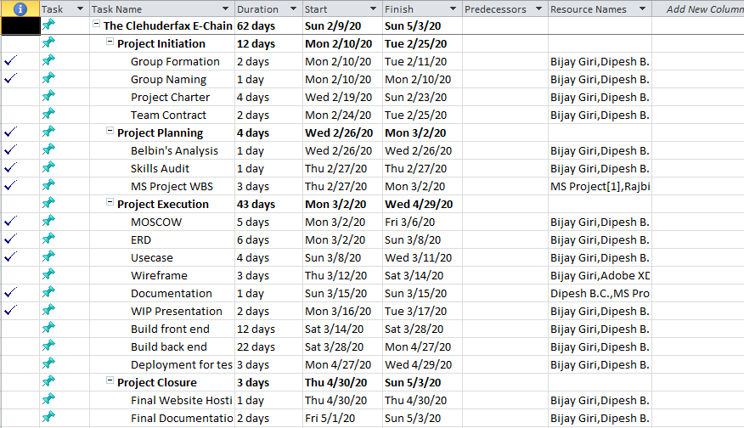

### Gantt Chart

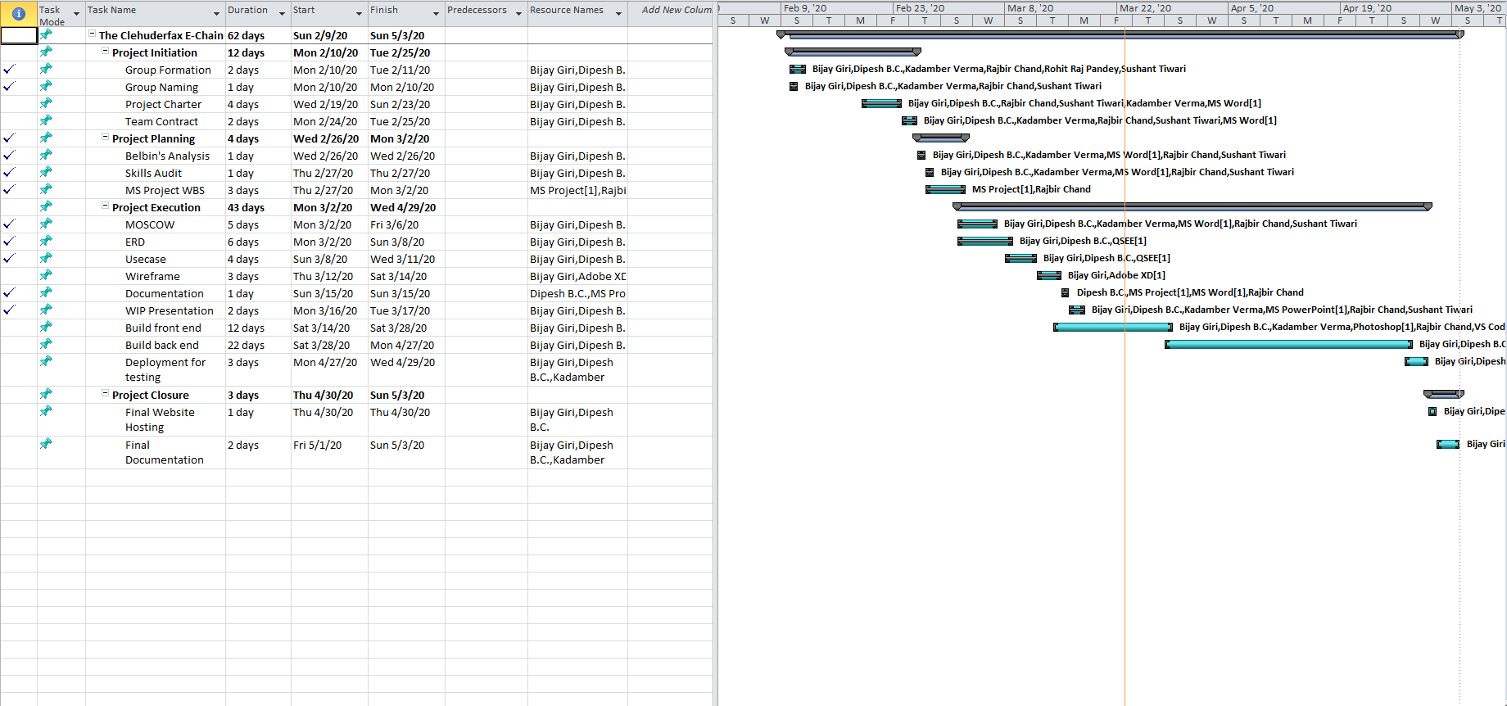

### Resource Sheet

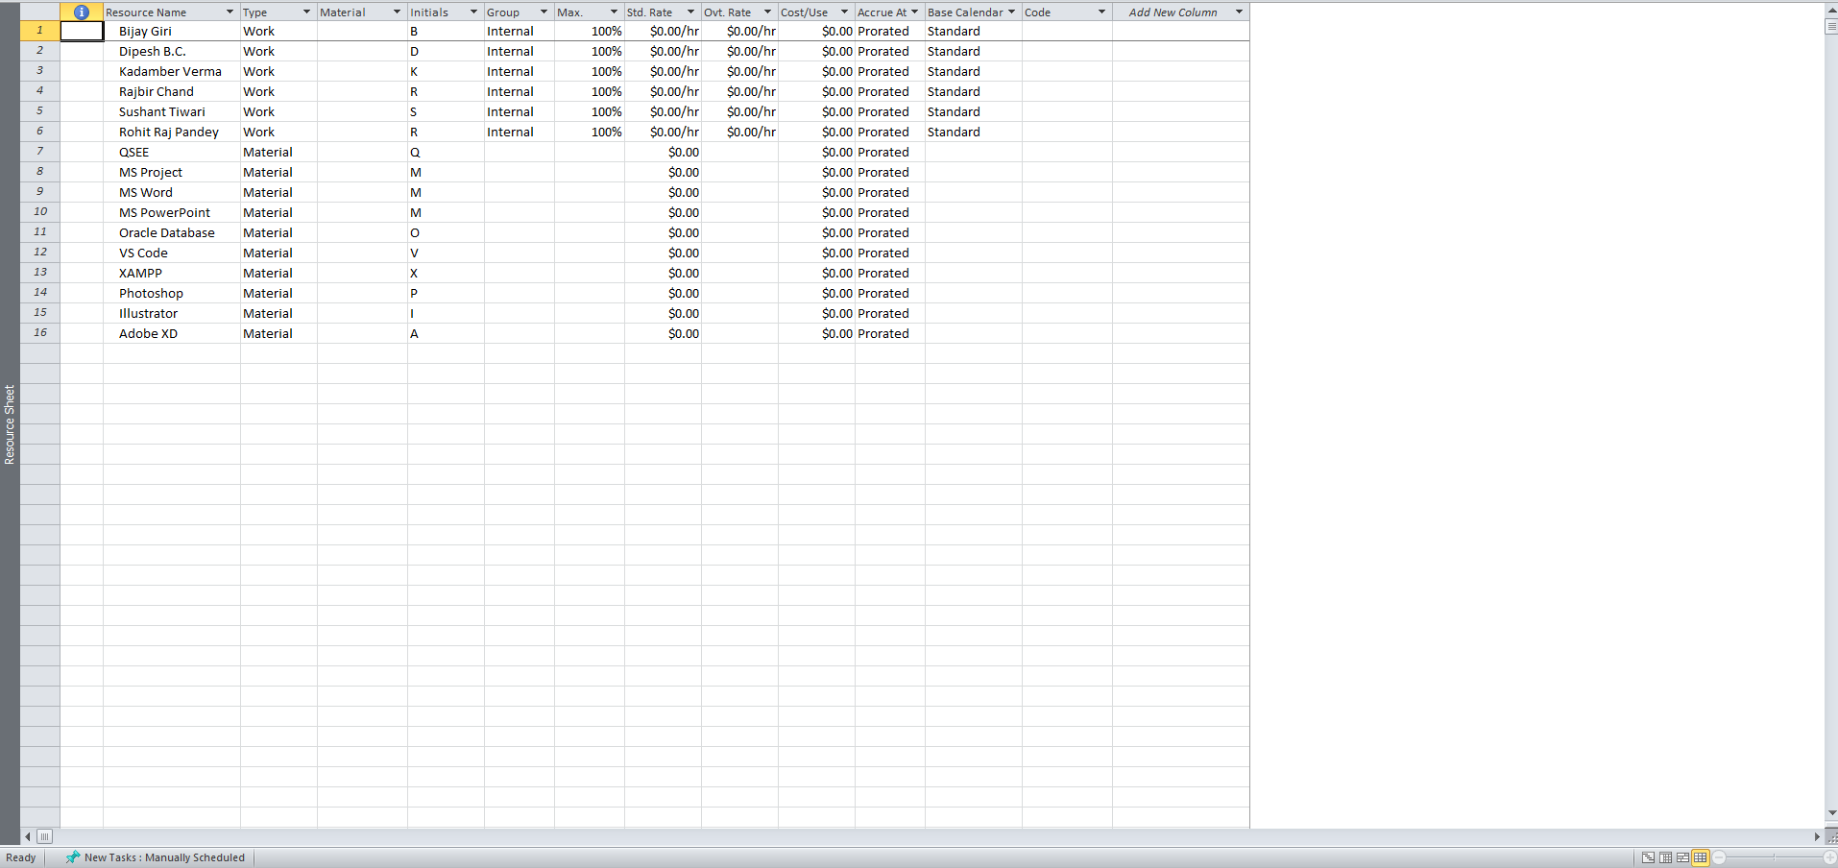

### Calendar

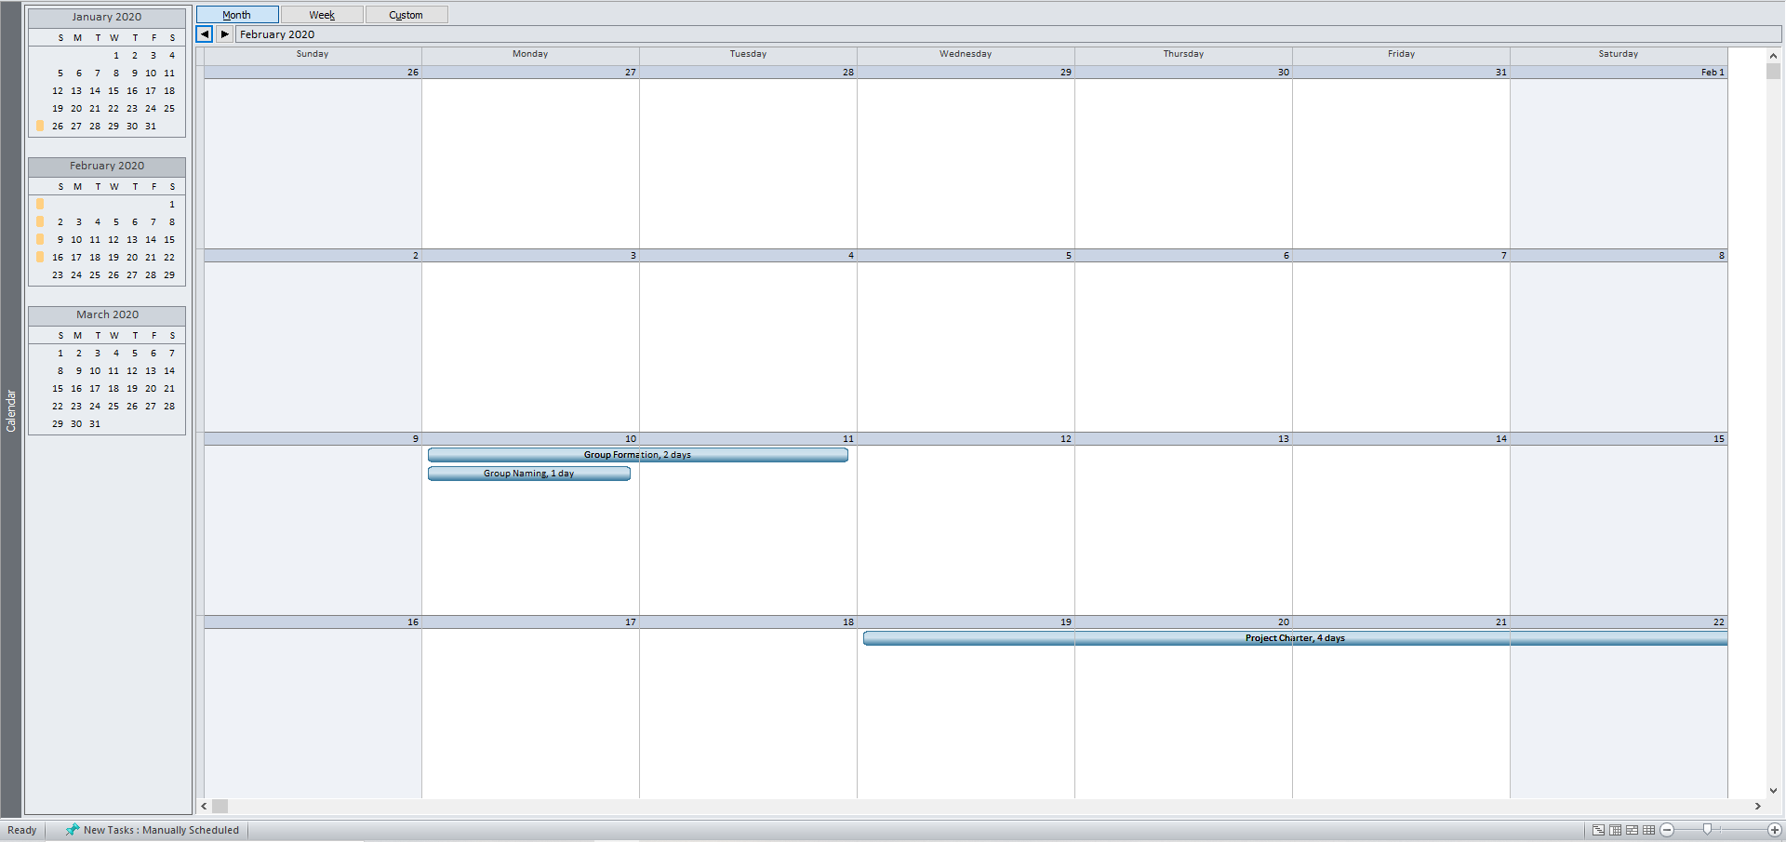

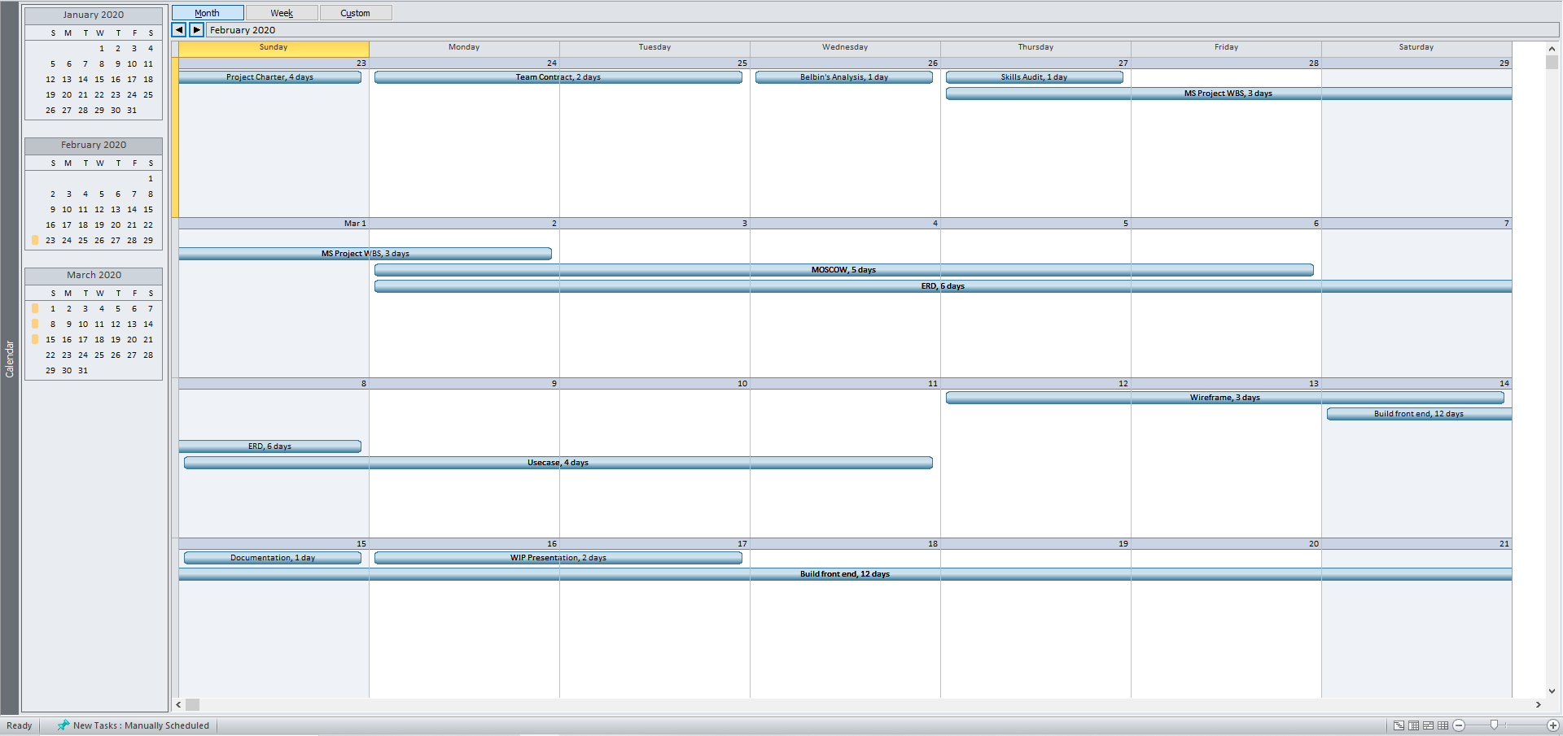

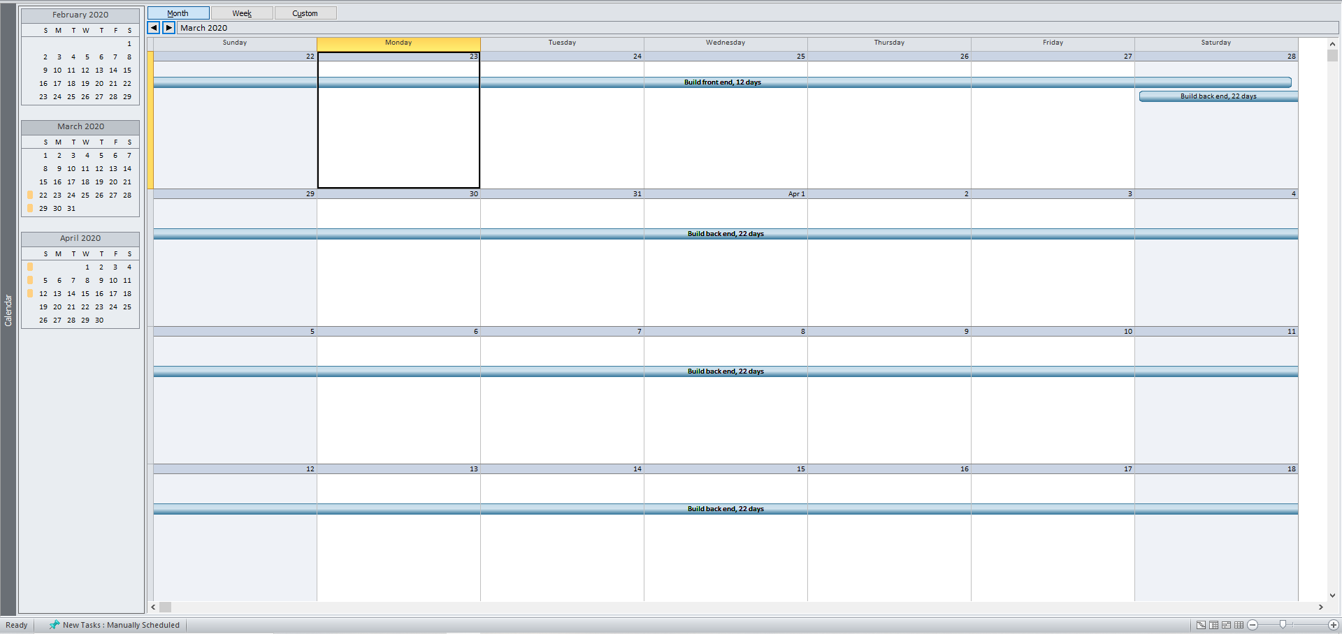

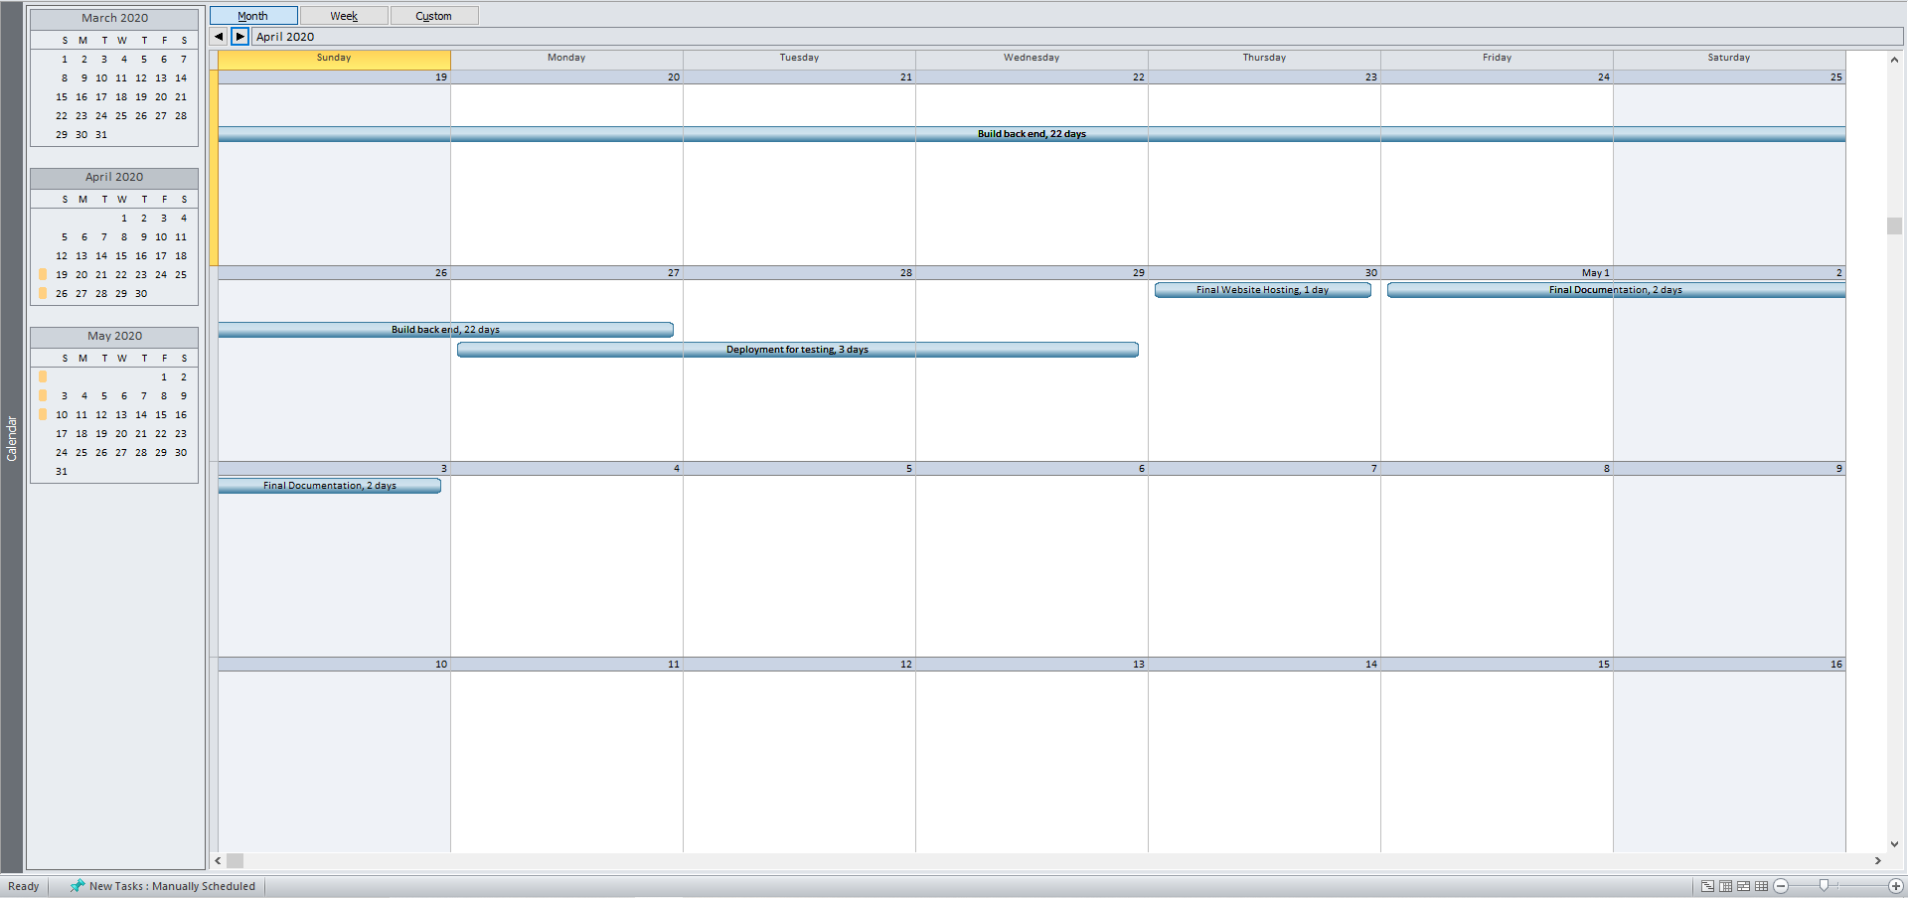

### Timeline

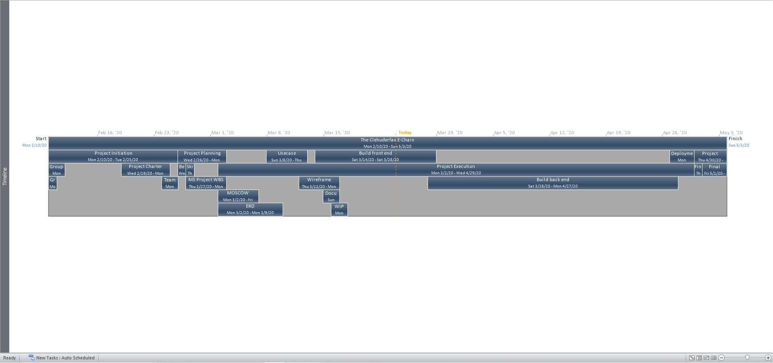

# **Communication and Collaboration Tools Used**

## Trello

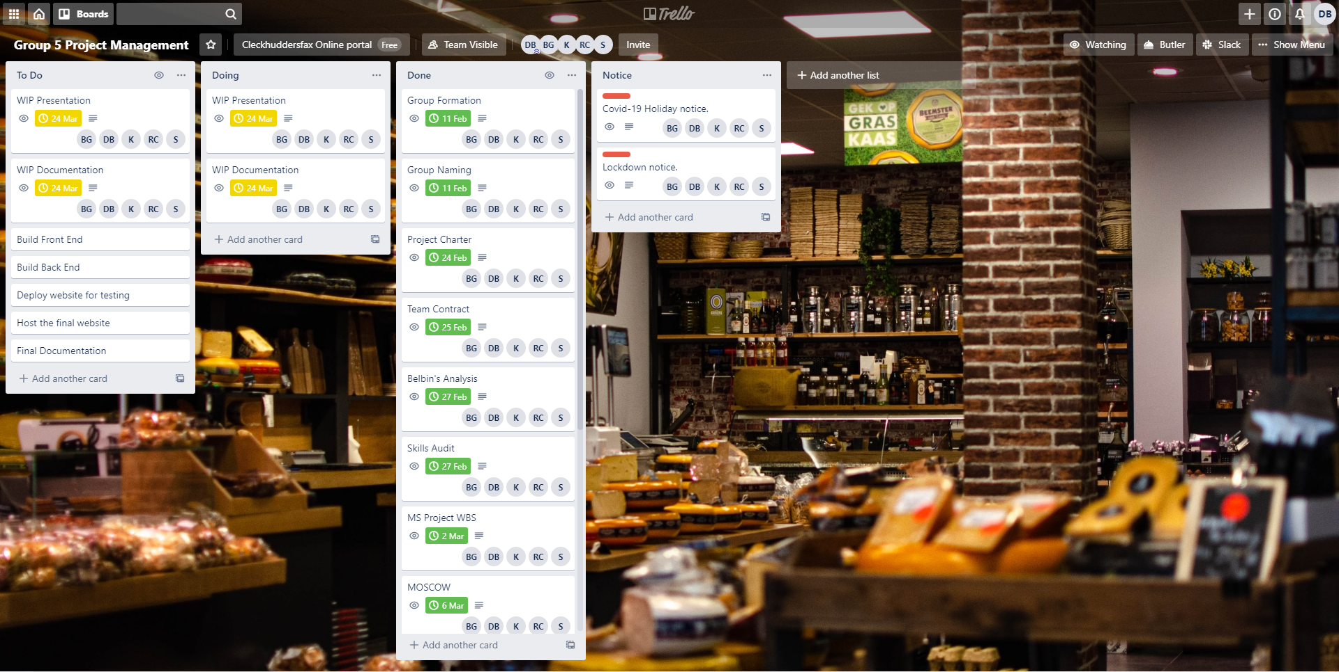

## Slack

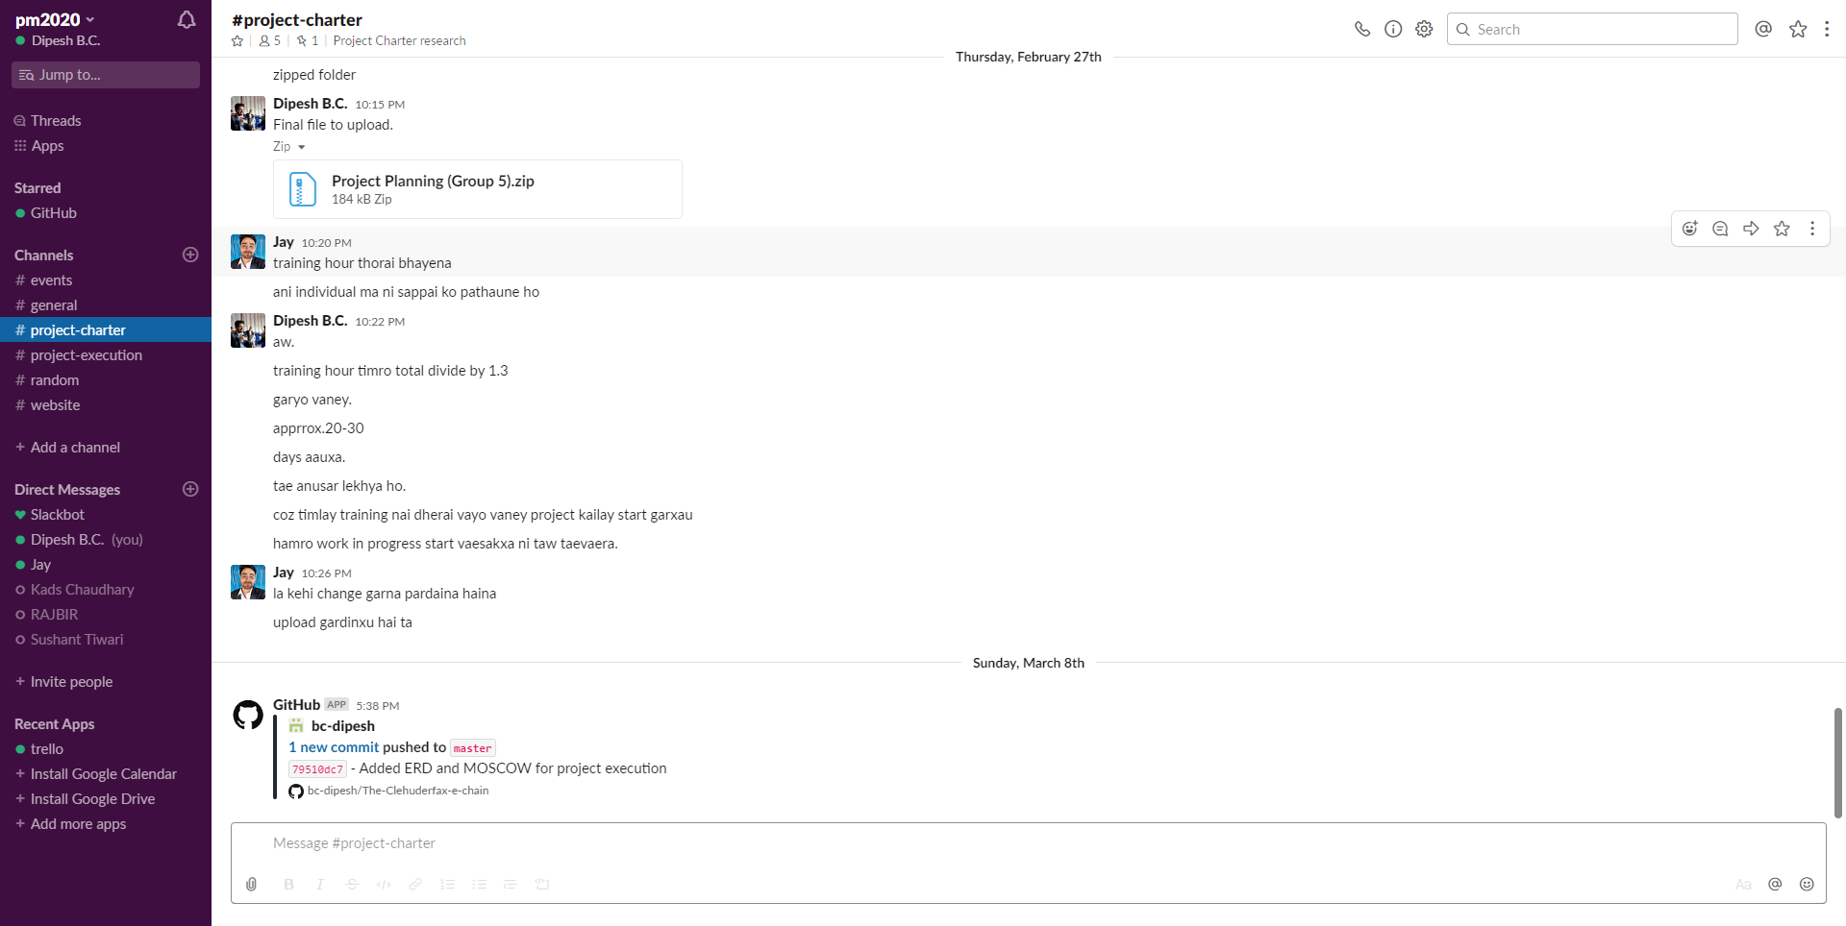

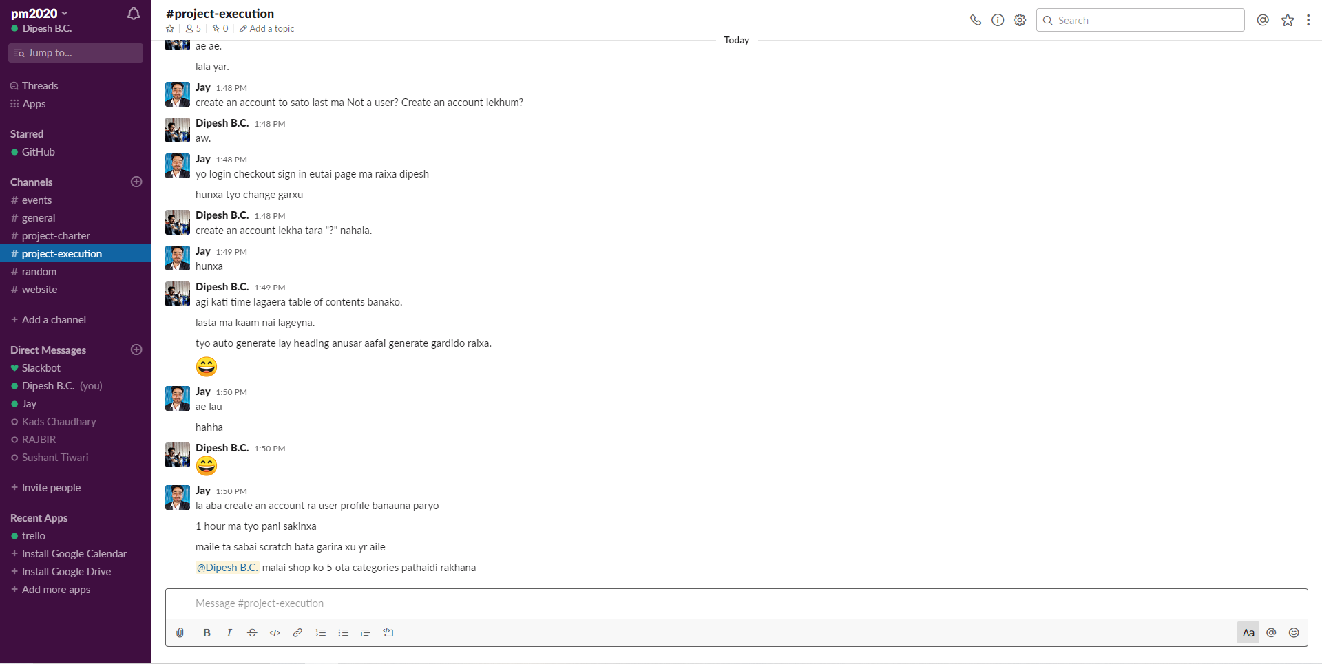

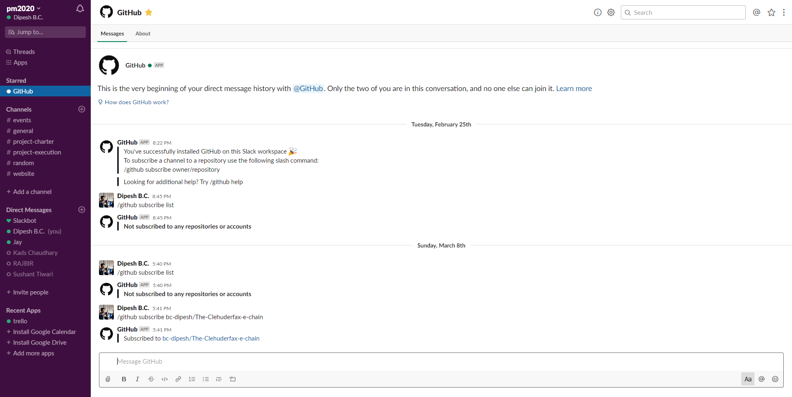

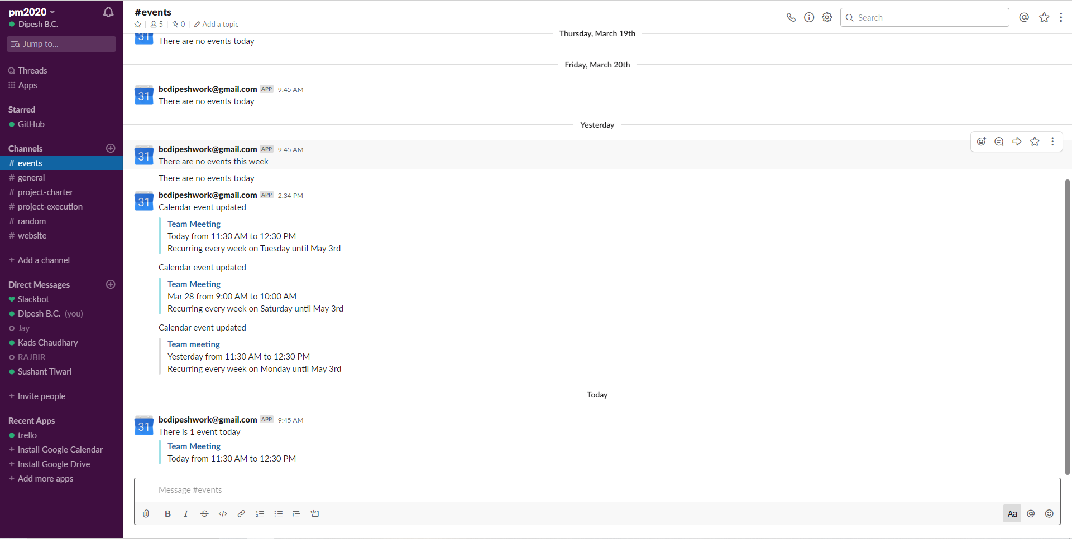

# **Product Designing**

## Entity Relationship Diagram

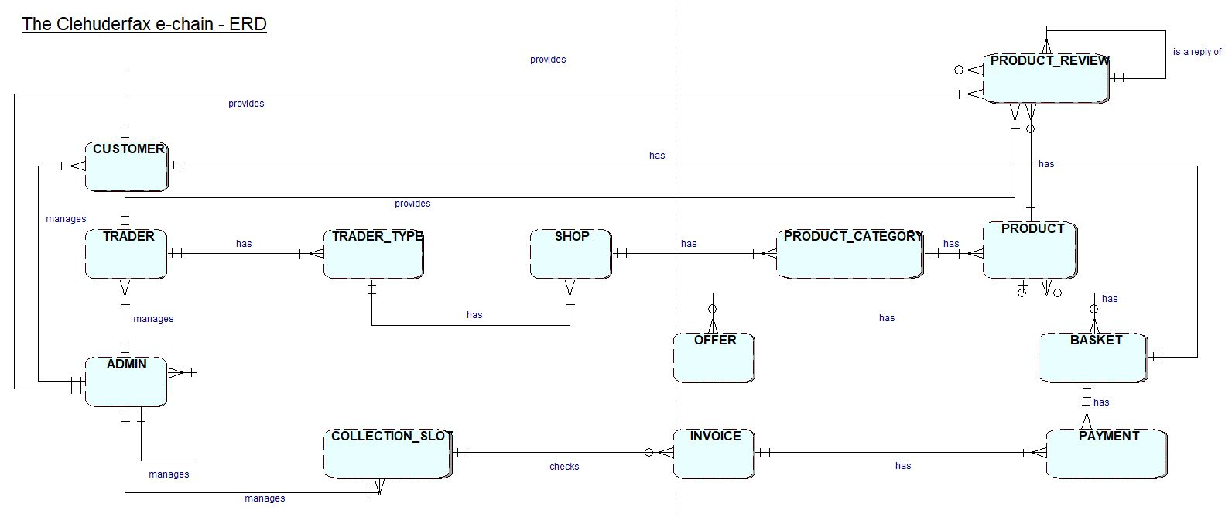

## Extended Entity Relationship Diagram

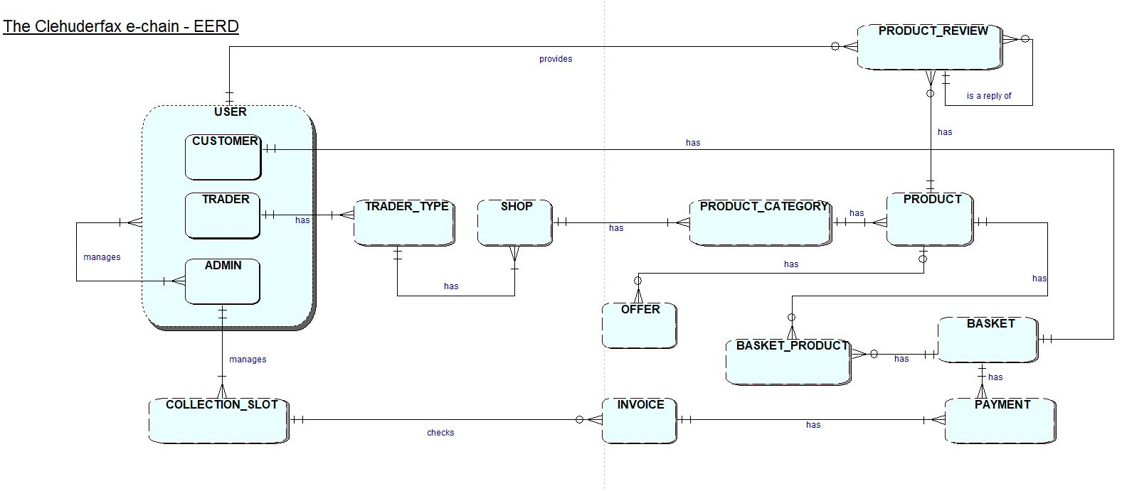

## Final Composite Entity Relationship Diagram

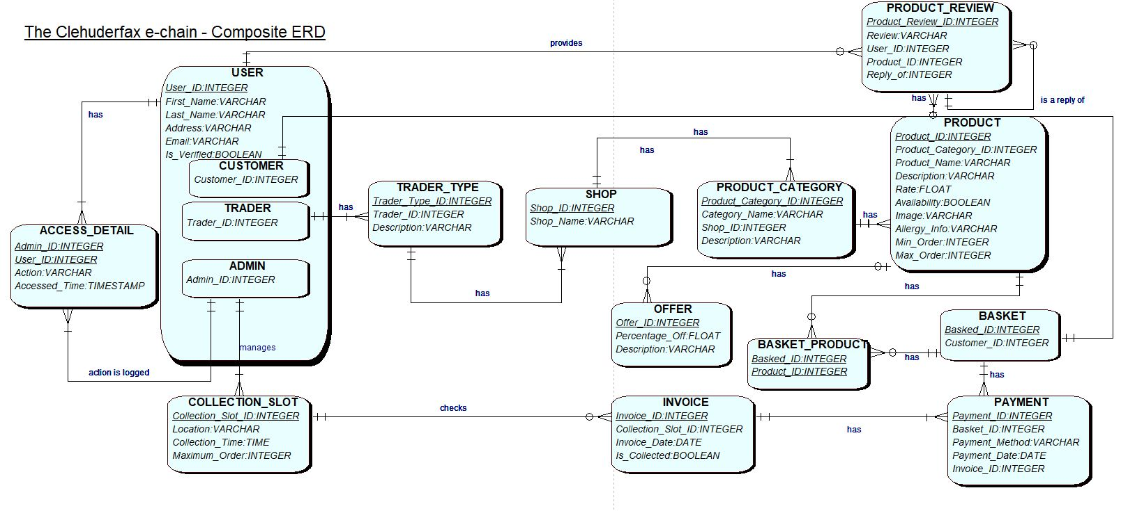

# **Use Case Diagram**

## Overview

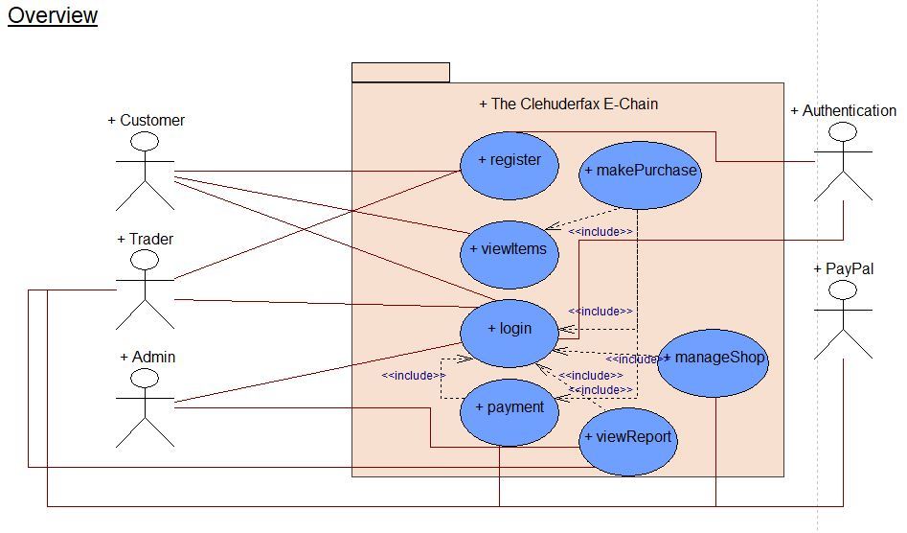

## Customer

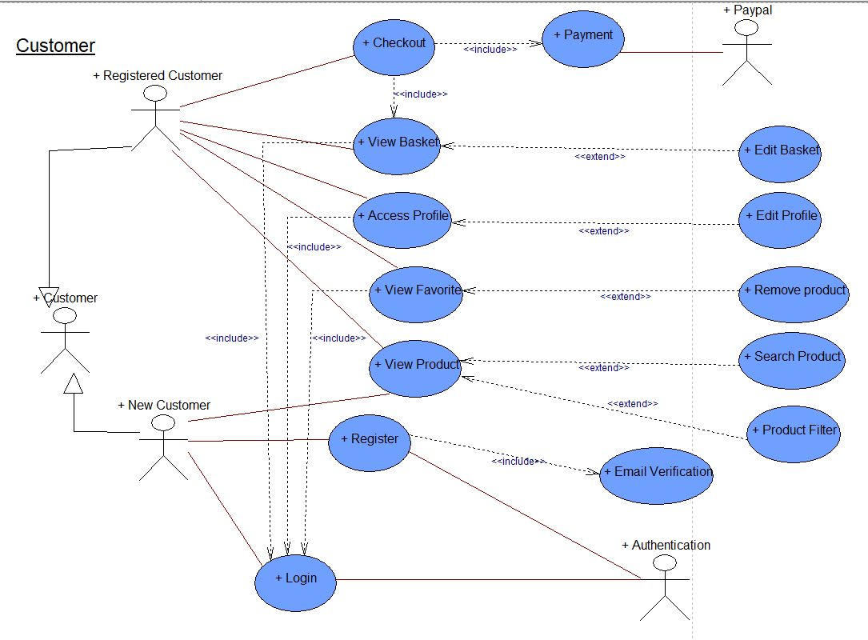

## Trader

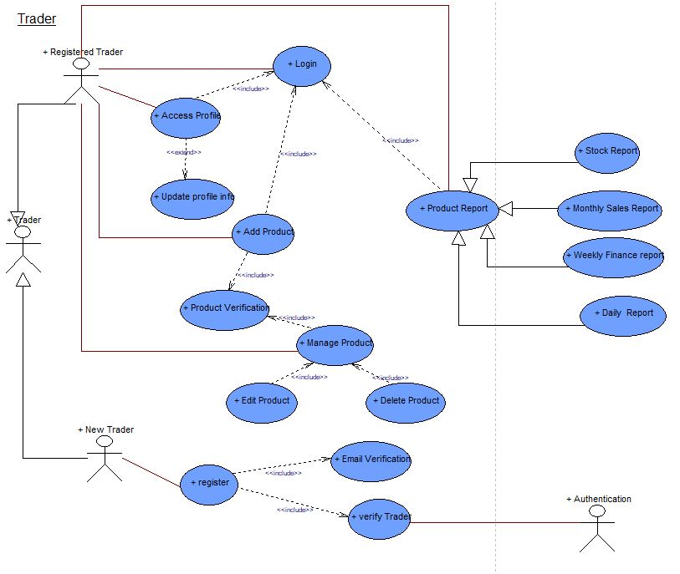

## Admin

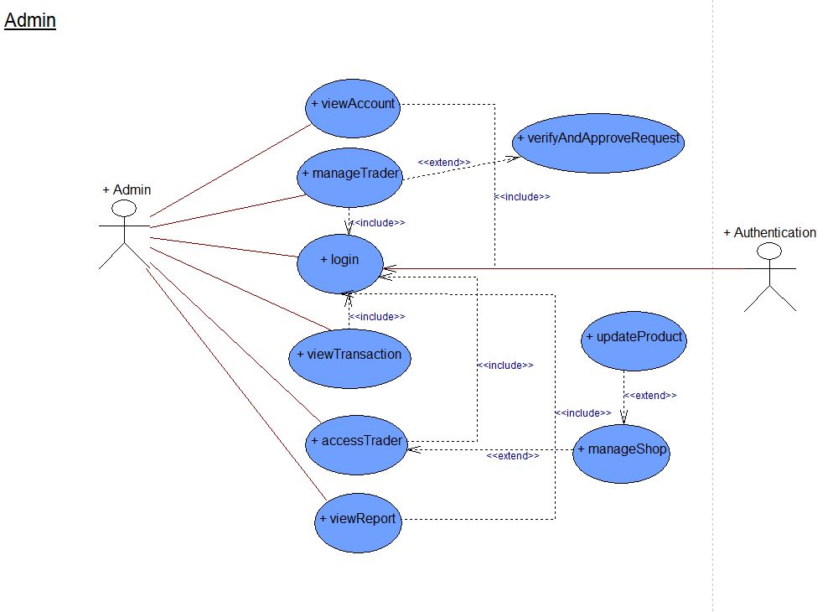

# **Requirement Catalogue**

## Functional Requirements

### Part A: Customer Interface

|  |  |  |
| --- | --- | --- |
| REQUIREMENT ID | DESCRIPTION | MOSCOW RULE |
| A1-F | **An Interface that allows the customers to view product** |  |
| A1F-01 | Users should be able to navigate products by shop or by product type. | **M** |
| A1F-02 | The product of each traders will not overlap, and products will be unique to them. | **M** |
| A1F-03 | Viewable on mobile as well as desktop devices and viewable on the most popular browsers. | **M** |
| A1F-04 | Each product will have name, product type, short description, quantity, price, image and traders. | **M** |
| A1F-05 | Customer registration and login system. | **M** |
| A1F-06 | Customer will be able to view ten shops. | **M** |
| A1F-07 | Customer will be able to check out and select collection slots. | **M** |
| A1F-08 | Customers will be able to make payment via online payment gateway. | **M** |
| A1F-09 | Users will be able to search products by open search. | **S** |
| A1F-10 | Users will be able to access their account and can update, edit, delete their account info including profile pictures. | **S** |
| A1F-11 | Users will be able to rate a product and provide a product review. | **S** |
| A1F-12 | Users will be able to sort products using filter such as price, ascending and descending order. | **S** |
| A2F | **The Interface will allow the customers to select activities to temporarily store in a favorites collection** |  |
| A2F-01 | Single basket that holds goods that spans all traders and requires a single payment. | **M** |
| A2F-02 | Customers will be able to view their orders | **M** |
| A2F-03 | Customers will be able to view total price | **M** |
| A2F-04 | The Cart will list product with a thumbnail image, price, quantity, total price and checkout or indicate no favorites are saved. |  |
| A2F-05 | Customers should be able to remove individual item or all from cart | **S** |
| A2F-06 | Customers should be able to shop again before checking out. | **S** |
| A2F-07 | Add to favorites link will appear for logged in users only. | **C** |
| A2F-08 | Add to favorites link will appear beside every product | **C** |
| A2F-09 | Customers should be able to clear individual or all item from favorites. | **C** |
| A2F-11 | The favorite’s page will list all favorites thumbnail image, product name and added time or indicate no favorites are saved. | **C** |

### Part B: Registration and Login

|  |  |  |
| --- | --- | --- |
| REQUIREMENT ID | DESCRIPTION | MOSCOW RULE |
| B1F | **Interface that allows new user registration and user login** |  |
| B1F-01 | A login form for collecting username/email and password. | **M** |
| B1F-02 | Login button will be displayed on every page if the user is not logged in. | **S** |
| B1F-03 | Registration form for unregistered user login attempt. | **M** |
| B1F-04 | Server-side validation for user registration and user login. | **S** |
| B1F-05 | Server validation that informs users if they attempt to  log in using incorrect details | **M** |
| B2F | **Interface for user and trader login** |  |
| B2F-01 | A form that collects first name, last name, email, address, mobile number, password and terms and conditions checkbox for user registration | **S** |
| B2F-02 | User registration confirmation through email address | **S** |
| B2F-03 | A form that collects first name, last name, email, address, mobile number, shop name, password and terms and conditions checkbox for trader registration | **S** |
| B2F-04 | Traders registration confirmation through email address | **S** |
| B2F-05 | Server-side validation so that none of the fields are left empty or filled with wrong data. | **S** |
| B2F-06 | Password should be encrypted before storing in database | **S** |
| B2F-07 | Application of appropriate functions and techniques  to combat security risks posed by data being entered  into form | **S** |
| B2F-08 | Application of appropriate functions and techniques  to ensure validity of data entered including valid  email; names - alpha only; password includes at least  one capital letter, a number and a symbol | **C** |

### Part C: Trader Interface

|  |  |  |
| --- | --- | --- |
| REQUIREMENT ID | DESCRIPTION | MOSCOW RULE |
| C1F | **Interface that allows allow authenticated traders to manage products** |  |
| C1F-01 | All products will have unique product ID, associated only with Trader. | **M** |
| C1F-02 | Traders should be able to login and access their details only. | **M** |
| C1F-03 | Homepage/dashboard for the trader | **M** |
| C1F-04 | Traders should be able to access CRUD operation for their shop products. | **M** |
| C1F-05 | Clicking the Delete link will remove the chosen item  and update the displayed catalogue of items  . | **S** |
|  |  |  |
| C1F-06 | Clicking the update link will show a form prepopulated with all editable details. Submitting the  form will update the chosen item and display the updated item. | **S** |
| C1F-08 | A facility will be provided to allow for the upload of  new images for a new item when added. | **C** |
| C1F-09 | Traders should be able to edit and modify their trader account. | **C** |
| C1F-10 | Traders will be able to login to the database daily to view reports on orders and stock levels. | **S** |

### Part D: Admin Interface

|  |  |  |
| --- | --- | --- |
| REQUIREMENT ID | DESCRIPTION | MOSCOW RULE |
| D1F | **A facility to allow authenticated admin users to**  **manage the activities presented by the system** |  |
| D1F-01 | An active admin link will be provided once an admin  user has logged in. | **S** |
| D1F-02 | Admin home page or dashboard for admin | **M** |
| D1F-03 | The admin page will display all activities with the  option to create a new item, delete or update each  item  . | **M** |
| D1F-04 | An admin login that can access any of the trader accounts. | **S** |

### Part E: Management Interface

|  |  |  |
| --- | --- | --- |
| REQUIREMENT ID | DESCRIPTION | MOSCOW RULE |
| E1F | **A facility to allow authenticated admin users to**  **manage the activities presented by the system** |  |
| EF-01 | A management dashboard is required. | **M** |
| EF-02 | Management dashboard should provide the traders access to a range of daily and periodic reports | **S** |
| EF-03 | Daily reports will be generated which will identify the goods and quantities that have been ordered. | **M** |
| EF-04 | Reports should be presented so that it is clear which delivery slots goods are required for and they will use this information to label goods for collection with a  customer ID and order ID as well as product details. | **M** |
| EF-05 | Traders will be provided with a weekly finance report which will identify payments to be made | **S** |
| EF-06 | Traders will be provided with a monthly report on their product sales | **S** |
| EF-07 | Report can be viewed ordered in several ways: alphabetically, by total number of orders per product, by total income per product. | **S** |

## Non-Functional Requirements

### Part F: Non-Functional Requirement

|  |  |  |
| --- | --- | --- |
| REQUIREMENT ID | DESCRIPTION | MOSCOW RULE |
| F1F | **The website will comply with the following nonfunctional requirements** |  |
| FF-01 | HTML/CSS template suited to requirements. | **M** |
| FF-02 | Website designed as per wireframe | **M** |
| FF-03 | Template applied consistently throughout the site | **S** |
| FF-04 | Site built for maintainability: Files organized,  comments added, HTML using includes, bespoke  functions. | **S** |